COSC 3380

Name: ______________ Seat# ___
Project 3:
(100 points.)
(Due date found in the COSC 3380 Detailed Syllabus!)

1. a. Create stored procedure ProductLineSale _______ 20 points
1. b. Run ProductLineSale ______ 5 points
1. c. Display PRODUCT 5 points

2. a. Create trigger StandardPriceUpdate 20 points
2. b. Run trigger StandardPriceUpdate _ 10 points

3. JSP Web Page SalestoDate.jsp ___ 40 points

PLEASE ENTER YOUR GRADE IN THIS BOX & ALSO on the CHECK SHEET:

Use the COSC3380 Database created in Project 2.

Part 1. (30 points) Stored Procedures

1. (30 points)
a. (20 points)
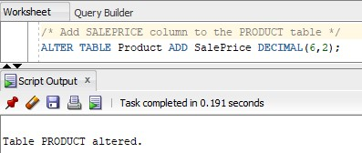

b. (5 points)
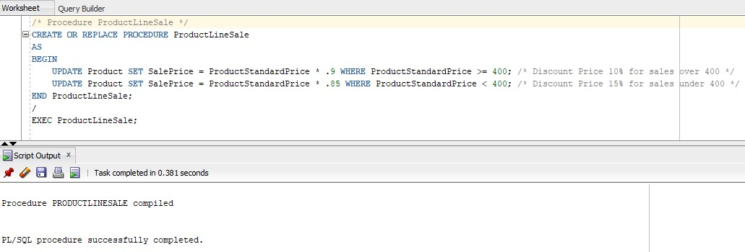

c. (5 points)
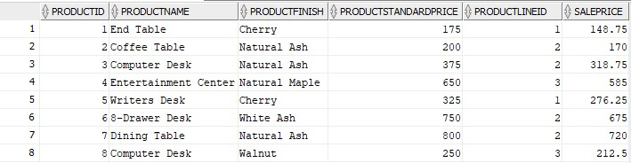
Part 2. TRIGGERS (30 points)
- (20 points) Write and

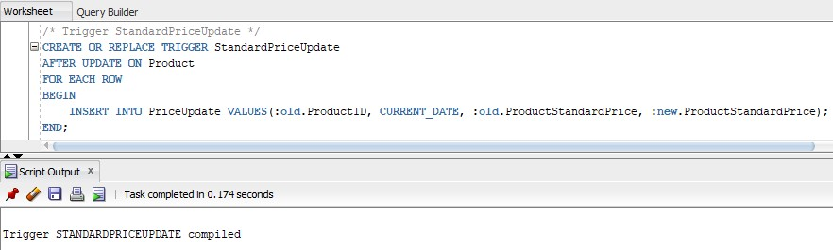
- (10 points) Run the trigger named StandardPriceUpdate
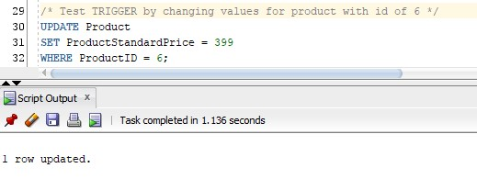
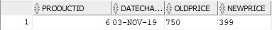

Part 3. (40 points) Accessing COSC3380 Database from JSP
(PHP (Optional)
ASP (Optional))

Create a simple Web Page whose purpose is to display SalestoDate from the database, a report that will be used by the Product Manager (product ID, product description, #number of times the product was ordered.

A JSP Web Page (40 points)
Create SalestoDate.jsp

(jsp page oracle 12c DBMS backend)
(1.index.jsp;
2. NetBeans Project with source; project and output;
3. web page screenshot)

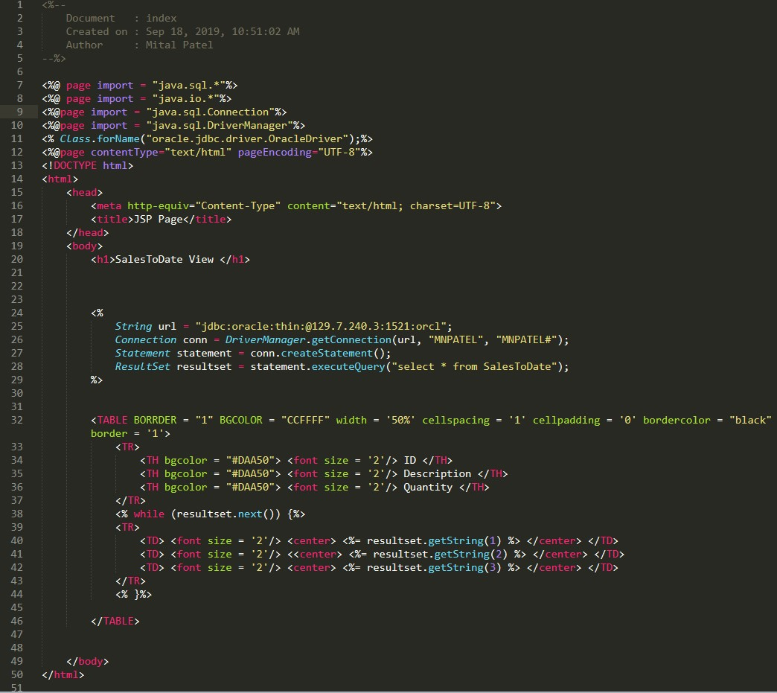
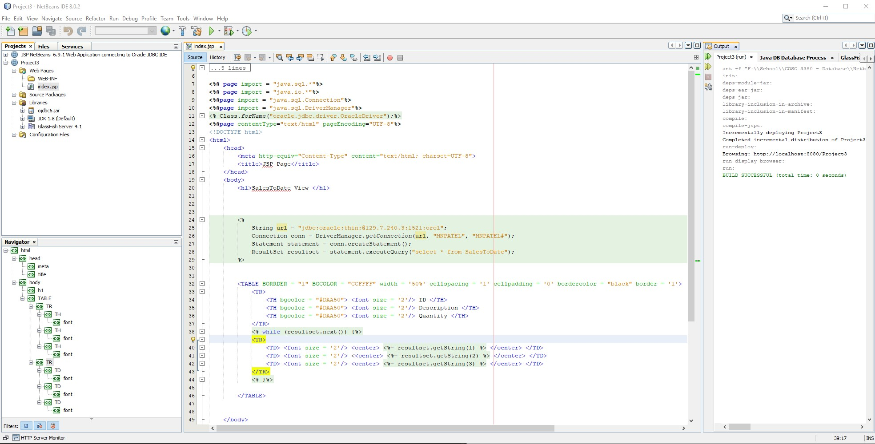
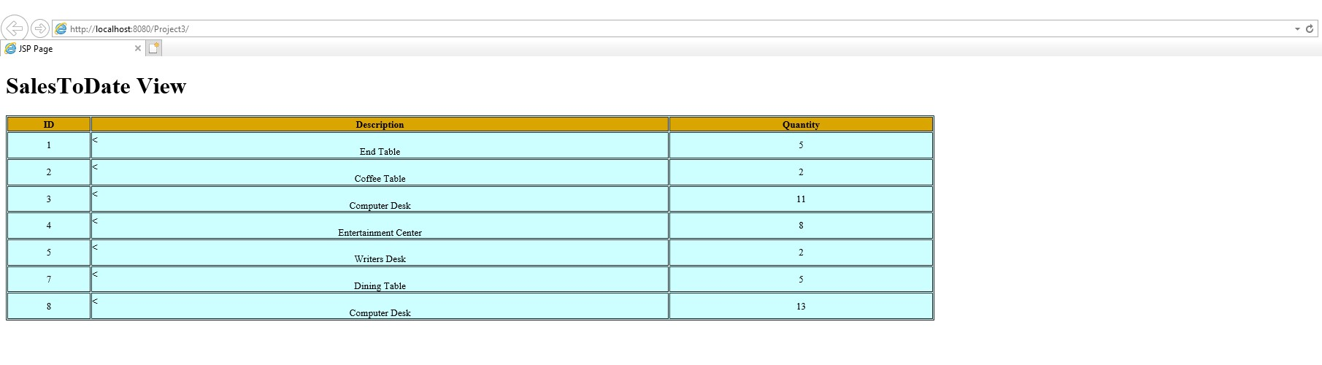

You need to turn in hard copy and electronic:
. The .sql scripts with comments, Project3.sql.
. The .zip of the 3 Projects (2 NetBeans; 1 Visual Studio). (only to BB)

. The screenshots of Stored Procedures, Trigger, NetBeans 6.9.1 & Visual Studio 2010 Projects, Web Pages AND the source CODE, Project3.doc. (BOTH to BB and HARDCOPY)

Without Project3.doc you will get ZERO!

You are to download your ZIPPED ASP.NET Project / NetBeans Project/ PHP Project into BB then to your local computer in 232 PGH in the first 10 minutes of the class.
PLEASE DO NOT RAR!

